**DSP LAB 1 REPORT**

**Dekun Xie 210337152**

**2.2 Plot peak period and wave height**

1. [data, count] = readbuoydata('C:\MisterDK\Queen Mary University of London\Courses\Digital Signal Processing\LAB ASSESSMENTS\LAB1\images\045200603.txt');
2. hs = data.Hs;
3. tp = data.Tp;
4. date = data.date;
6. t = tiledlayout(2,1); %构建布局
7. ax1 = nexttile;
8. plot(date, hs);
9. ylabel("Significant Wave Height (m)");
11. ax2 = nexttile;
12. plot(date, tp);
13. ylabel("Peak Period (s)");
14. xlabel(ax2,'Time');
16. dateformat = 'mm-dd';
17. linkaxes([ax1,ax2], 'x'); %同步两个x轴对齐
19. xticklabels(ax1,{}); %清空第一个x轴
20. t.TileSpacing = 'compact'; % 两个图更紧凑
22. datetick('x', dateformat,'keepticks');

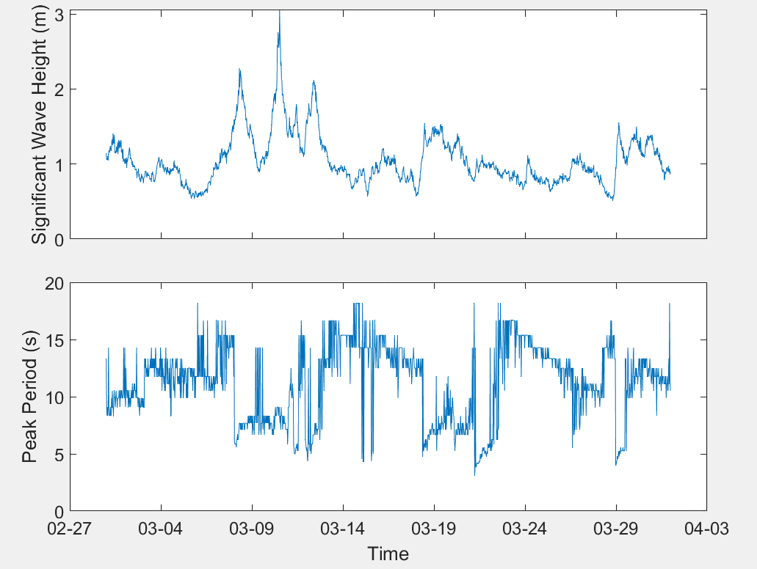

**2.3 Moving average**

1. function y = mov_avg(x, M)
3. size = length(x);
5. x = [zeros(1,M - 1), x];
7. **for** n = 1  : size
8. sum = 0;
9. **for** k = 0 : M - 1
10. sum = sum + x(n + M - 1 - k);
11. end
12. y(n) = sum/M;
13. end

**2.4 Using moving average function**

1. [data, count] = readbuoydata('C:\MisterDK\Queen Mary University of London\Courses\Digital Signal Processing\LAB ASSESSMENTS\LAB1\images\045200603.txt');
2. hs = data.Hs;
3. tp = data.Tp;
4. date = data.date;
6. t = tiledlayout(3,1); %构建布局
7. ax1 = nexttile;
8. plot(date, tp,'Color',[0.8 0.8 0.8],'LineWidth',2);
9. hold on;
10. plot(date, mov_avg(tp,5));
11. ylabel("Peak Period (s)");
12. title('M = 5')
14. ax2 = nexttile;
15. plot(date, tp,'Color',[0.8 0.8 0.8],'LineWidth',2);
16. hold on;
17. plot(date, mov_avg(tp,21));
18. ylabel("Peak Period (s)");
19. title('M = 21')
21. ax3 = nexttile;
22. plot(date, tp,'Color',[0.8 0.8 0.8],'LineWidth',2);
23. hold on;
24. plot(date, mov_avg(tp,51));
25. ylabel("Peak Period (s)");
26. xlabel(ax3,'Time');
27. title('M = 51')
29. dateformat = 'mm-dd';
30. linkaxes([ax1,ax2, ax3], 'x'); %同步两个x轴对齐
32. xticklabels(ax1,{}); %清空第一个x轴
33. xticklabels(ax2,{}) ;%清空第一个x轴
35. t.TileSpacing = 'compact'; % 两个图更紧凑
37. datetick('x', dateformat,'keepticks');

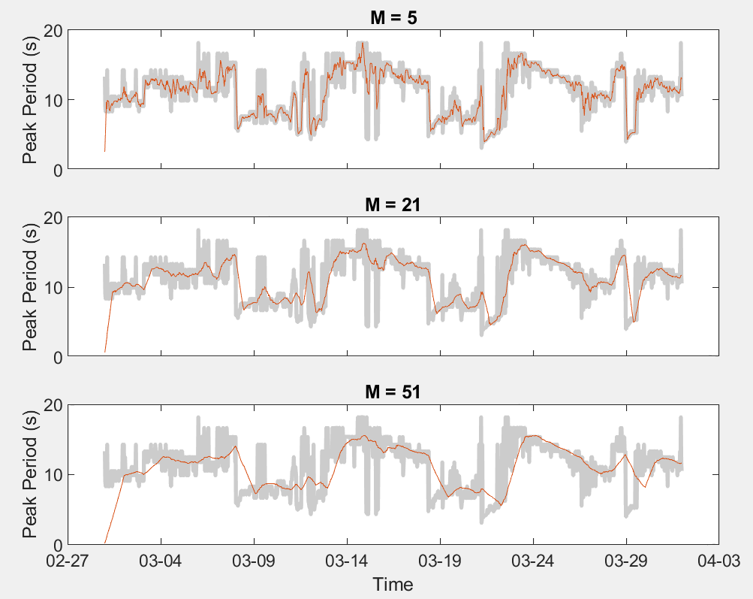

**2.5**

**2.5.1 What do you observe in the plots when M increases?**

The lines become smoother and the peak gets lower.

**2.5.2 Why do you think you observe this “thing”?**

As there is a window of size M moving and averaging the data points, the high data point gets lower and the low one gets higher and it shorten the difference between every data point, which causes the smooth trend and decrease in peak. When M increases, the level of the average become higher as well and then the lines become smoother and the peak gets lower.

**2.5.3 What is happening at the beginning of the averaged data set, and why does this happen?**

A few data points got a sharp decrease compared with the original data. As these data points are averaged with at most M – 1 0 value points and mainly affected by the 0 value.

**2.5.4 What happens to the running average when the peak period suddenly drops?**

The sharpness of the edge is reduced.

**2.5.5 Are these drops preserved?**

No.

**2.5.6 Are the wave trains more clear?**

Yes.

**2.6 Repeat 2.4 for the Hs data using the same . Include your plots, but this time not your code.**

1. [data, count] = readbuoydata('C:\MisterDK\Queen Mary University of London\Courses\Digital Signal Processing\LAB ASSESSMENTS\LAB1\images\045200603.txt');
2. hs = data.Hs;
3. tp = data.Tp;
4. date = data.date;
6. t = tiledlayout(3,1); %构建布局
7. ax1 = nexttile;
8. plot(date, hs,'Color',[0.8 0.8 0.8],'LineWidth',2);
9. hold on;
10. plot(date, movmean(hs,5));
11. ylabel("Significant Wave Height (m)");
12. title('M = 5')
14. ax2 = nexttile;
15. plot(date, hs,'Color',[0.8 0.8 0.8],'LineWidth',2);
16. hold on;
17. plot(date, movmean(hs,21));
18. ylabel("Significant Wave Height (m)");
19. title('M = 21')
21. ax3 = nexttile;
22. plot(date, hs,'Color',[0.8 0.8 0.8],'LineWidth',2);
23. hold on;
24. plot(date, movmean(hs,51));
25. ylabel("Significant Wave Height (m)");
26. xlabel(ax3,'Time');
27. title('M = 51')
29. dateformat = 'mm-dd';
30. linkaxes([ax1,ax2, ax3], 'x'); %同步两个x轴对齐
32. xticklabels(ax1,{}); %清空第一个x轴
33. xticklabels(ax2,{}) ;%清空第一个x轴
35. t.TileSpacing = 'compact'; % 两个图更紧凑
37. datetick('x', dateformat,'keepticks');

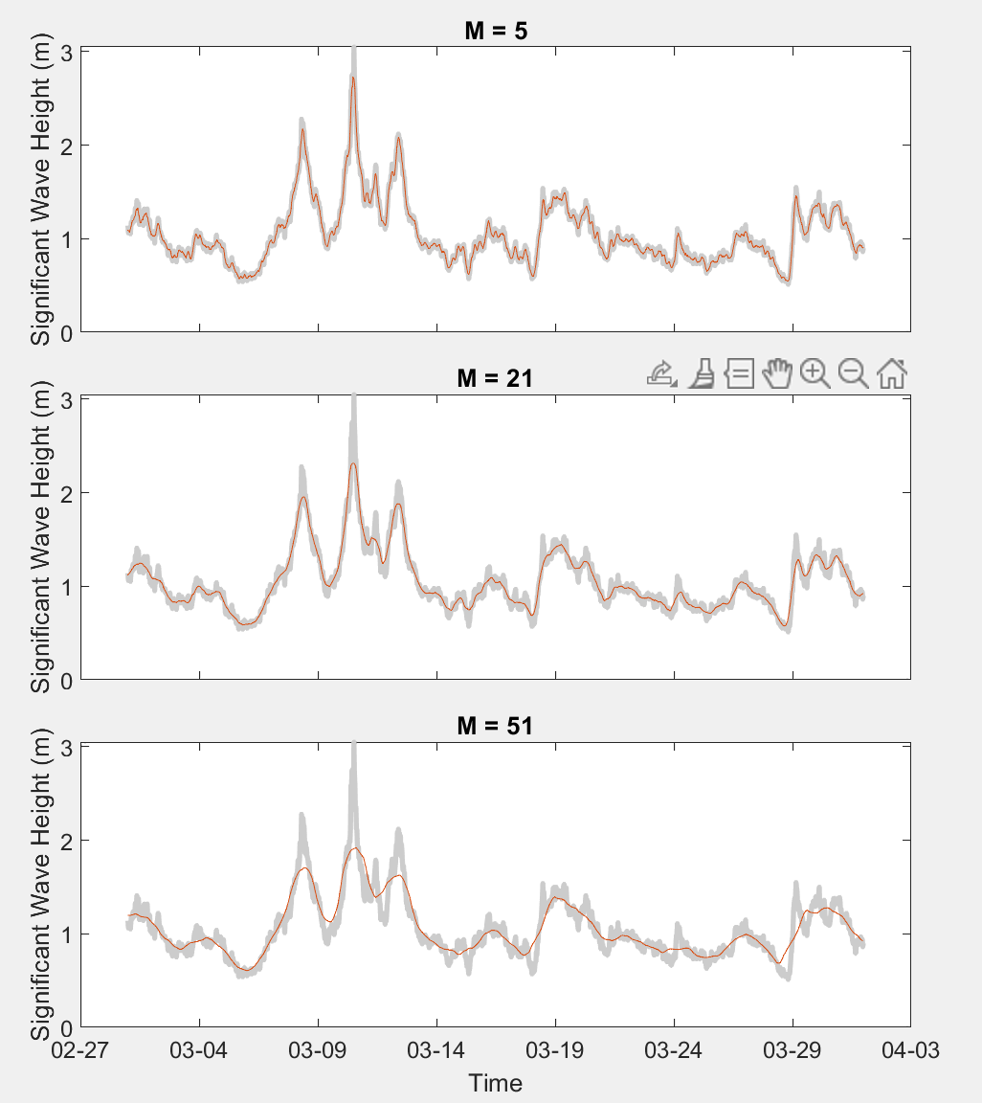

**2.7 Do you observe anything different in the plots from 2.6 to those you had in 2.4? When increases, what happens to the peaks in the data? How does the size of this effect relate to? Explain why the peaks move.**

①The position of the peak after averaged is the same as that of the original date in 2.6 when the peak after averaged moves to right in 2.4 compared with the original data.

②The peak gets lower and more shift (right in 2.4) as M increases;

③The size of M and whether the if the date is averaged symmetrically (one side or both side)

④The peak gets lower for averaged by the surrounding points.

The peak X[n] gets shift: as Y[n] equals to average of X[n] + X[n-1] +…+ X[n -M + 1] (X[n-1] … X[n -M + 1] are smaller than X[n] with high possibility), the peak Y[n] will become smaller than original peak X[n] after averaged. Similarly, X[n+1] which is right to the peak will probably become larger after averaged with peak X[n] and then output a new peak Y[n+1]. It makes the right shift happen.

**2.8 Now redo 2.4 and 2.6 using equation (3) so that the time effect is corrected. Include your figure and code.**

1. function y = mov_avg_noncausual_m(x, M)
3. size = length(x);
5. x = [zeros(1,(M - 1)/2), x, zeros(1,(M - 1)/2)];
7. **for** n = 1 : size
8. sum = 0;
9. **for** k = -(M-1)/2 : (M-1)/2
10. sum = sum + x(n + (M - 1)/2 - k);
11. end
12. y(n) = sum/M;
13. end

